**WT Assignment 5**

1. **List down the attributes of both entities. (user entity and respective topic entity.)**

**Entity:** Personal_details **Entity:** flower

**Attributes: Attributes:**

1)name 1)name

2)age 2)color

3)phone number 3)type

4)email id 4)price

5)state 5)location

6)gender 6)quantity

**2. Demonstrate following operations using PHP. (On your respective website)**

**i. Connection and creations of database and tables. (at least 2 tables)**

**1)**<?php

$conn=mysqli_connect("localhost","root","","personal_details");

if($conn)

{

echo"connected";

}

else

{

echo"connection failed";

exit();

}

$q3="CREATE TABLE P_D(ID INTEGER NOT NULL,

Name VARCHAR(20) NOT NULL,

Age INTEGER NOT NULL,

phone_no INTEGER NOT NULL,

email_id VARCHAR(30) NOT NULL,

state VARCHAR(30) NOT NULL,

gender VARCHAR(30) NOT NULL,

PRIMARY KEY (ID)

)";

$r3=mysqli_query($conn,$q3);

if($r3)

{

echo"<br>table created successfully";

}

else

{

echo"<br>failed to create table";

}

mysqli_close($conn);

?>

**OUTPUT:**

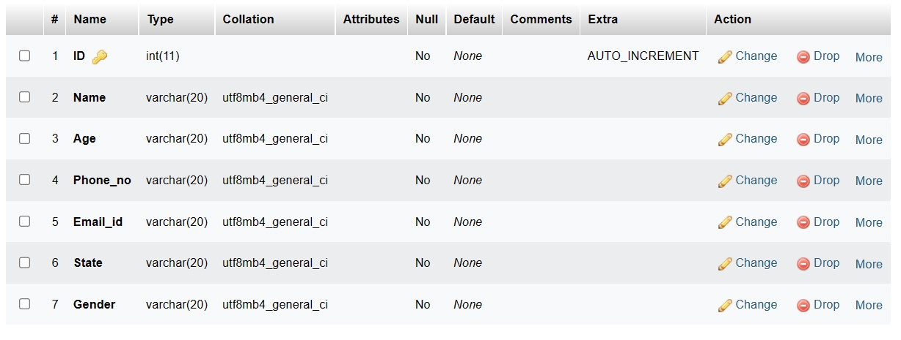

**2)** <?php

$conn=mysqli_connect("localhost","root","","Personal_details");

if($conn)

{

echo"connected";

}

else

{ echo"connection failed";

exit();

}

$q3="CREATE TABLE b_flower (ID INTEGER NOT NULL,

Name of flowers VARCHAR(10) NOT NULL,

Color of flowers VARCHAR(30) NOT NULL,

Type of flowers VARCHAR(30) NOT NULL,

Quantity of flowers VARCHAR(30) NOT NULL,

Location of flowers VARCHAR(30) NOT NULL,

Price of flowers VARCHAR(30) NOT NULL,

PRIMARY KEY(ID)

)";

$r3mysqli_query($conn,$q3);

if($r3)

{

echo"<br> flower table created successfully";

}

else

{ echo"<br>failed to create flower table";

}

mysqli_close($conn);

?>

**OUTPUT:**

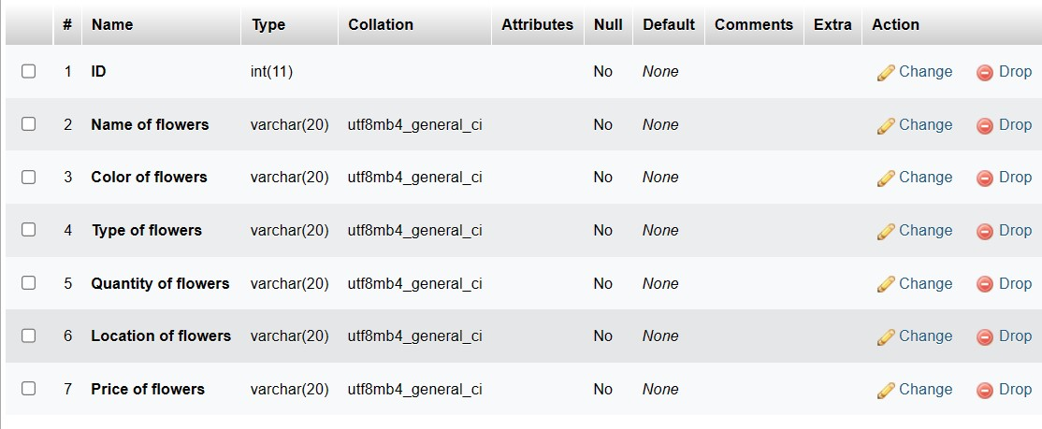

**ii. Data Insertion**

<!DOCTYPE html>

<html>

<head>

<title>Personal Information</title>

<style>

body{

background-image:url("form-background.PNG");

}

label{

background-color:aquamarine;

color:red;

}

h1{

background-image:url("head.JPG");

border-style:solid;

border-color:black;

border-radius:20px;

}

div{

background-image:url("cartwhite.JPG");

border-style:solid;

border-color:black;

border-radius:20px;

}

</style>

<?php

$conn=mysqli_connect("localhost","root","","personal_details");

if($conn)

{

echo"";

}

else

{

echo"connection failed";

exit();

}

if(isset($_POST["submit"]))

{

$name = $_POST["name"];

$age = $_POST["age"];

$phone = $_POST["phone"];

$emailid = $_POST["emailid"];

$state = $_POST["state"];

$country = $_POST["state"];

$gender = $_POST["gender"];

$query = "INSERT INTO form_details VALUES('', '$name', '$age', '$phone', '$emailid', '$state', '$gender')";

mysqli_query($conn,$query);

echo"Data Inserted Successfully";

}

mysqli_close($conn);

?>

</head>

<h1><center>Personal Information</center></h1>

<center><body>

<body>

<form class="" action="" method="post" autocomplete="on">

<label>Enter name:</label><br>

<input type="text" name="name" required value="">

<br><br>

<label>Enter age:</label><br>

<input type="number" name="age" required value="">

<br><br>

<label >Enter phone number: </label><br>

<input type="text" name="phone" required value="">

<br><br>

<label >Enter email id: </label><br>

<input type="email" name="emailid" required value="">

<br><br>

<label>Select state</label><br>

<select class="" name="state" required>

<option value="">Select state</option>

<option value="Goa">Goa</option>

<option value="Maharashtra">Maharashtra</option>

<option value="Karnataka">Karnataka</option>

</select>

<br><br>

<label>Select gender</label><br>

<br><input type="radio" name="gender" value="Male" required> Male

<br><input type="radio" name="gender" value="Female"> Female

<br><input type="radio" name="gender" value="Others"> Others

<br><br>

<button type="submit" name="submit">Submit</button>

<button type="reset" name="reset">Reset</button>

<br><br>

<div>

<br><br>

<ul style="list-style-type:circle;">

<b><li>“A flower does not think of competing with the flower next to it. It just blooms.” – Zen Shin.</li><br><br>

<li>“The Japanese say, if the flower is to be beautiful, it must be cultivated.” – Lester Cole.</li><br><br>

<li>“To plant a garden is to believe in tomorrow.” – Audrey Hepburn.

“Every flower must grow through dirt.” – Laurie Jean Sennott.</li></b>

</ul>

<br><br>

<a href="http://localhost/php_programs/flower.php">

<button type="button">Click here to fill flower information</button>

</a>

<br><br>

</div>

</form>

</body>

</html>

**OUTPUT:**

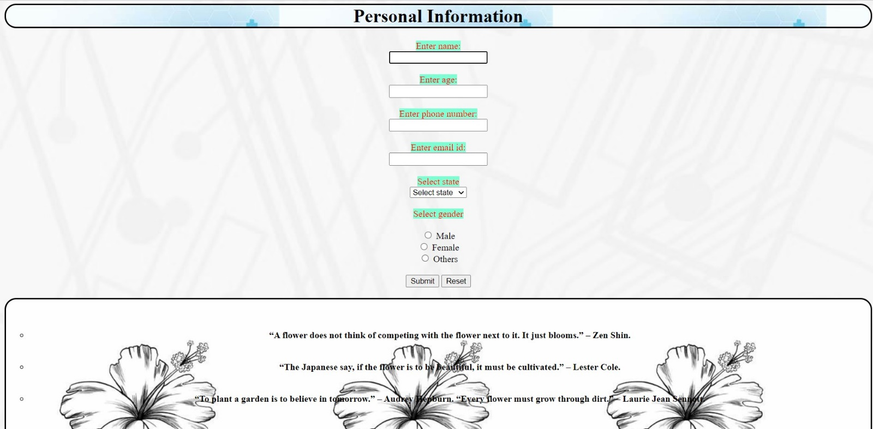

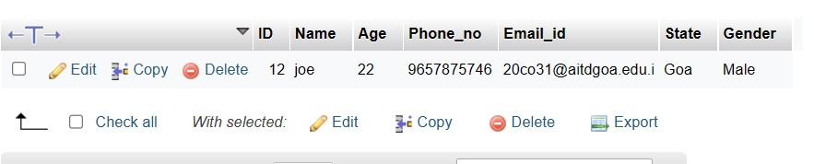

**2**) <!DOCTYPE html>

<html>

<head>

<title>Flower Information</title>

<style>

body{

background-image:url("form-background.PNG");

}

label{

background-color:aquamarine;

color:red;

}

h1{

background-image:url("head.JPG");

border-style:solid;

border-color:black;

border-radius:20px;

}

div{

background-image:url("flowerbuying.JPG");

border-style:solid;

border-color:black;

border-radius:20px;

}

</style>

<?php

$conn=mysqli_connect("localhost","root","","personal_details");

if($conn)

{

echo"";

}

else

{

echo"connection failed";

exit();

}

if(isset($_POST["submit"]))

{

$name = $_POST["name"];

$color = $_POST["color"];

$type = $_POST["type"];

$location = $_POST["location"];

$quantity = $_POST["quantity"];

$price = $_POST["price"];

echo"Data inserted successfully";

$q = "INSERT INTO b_flowers VALUES('', '$name', '$color', 'type', '$location', '$quantity', '$price')";

mysqli_query($conn,$q);

}

mysqli_close($conn);

?>

</head>

<h1><center>flower Information</center></h1>

<center><body>

<body>

<form class="" action="" method="post" autocomplete="on">

<label>Enter the name of flower:</label><br>

<input type="text" name="name" required value="">

<br><br>

<label>Enter the color of flower:</label><br>

<input type="text" name="color" required value="">

<br><br>

<label >Enter the type of flower: </label><br>

<input type="text" name="type" required value="">

<br><br>

<label >Enter the quantity of flowers: </label><br>

<input type="number" name="quantity" required value="">

<br><br>

<label>Select location</label><br>

<select class="" name="location" required>

<option value="">Select location</option>

<option value="Goa">Goa</option>

<option value="Maharashtra">Maharashtra</option>

<option value="Karnataka">Karnataka</option>

</select>

<br><br>

<label>Select price of flowers </label><br>

<br><input type="radio" name="price" value="100" required>100 rs

<br><input type="radio" name="price" value="200"> 200 rs

<br><input type="radio" name="price" value="300"> 300 rs

<br><br>

<a href="file:///C:/Users/mohan/Desktop/HTML/assi31CSS.html">

<button type="submit" name="submit">Submit</button>

<button type="reset" name="reset">Reset</button>

<br><br>

<div>

<br><br>

<a href="http://localhost/php_programs/hibiscus123.php">

<button type="button">Click here to visit our website</button>

</a>

<br><br>

<ul style="list-style-type:circle;">

<b><li>“Love is the flower you’ve got to let grow.” – John Lennon</li><br><br>

</li>“Life is the flower for which love is the honey.” – Victor Hugo</li><br><br>

<li>“A flower cannot blossom without sunshine, and man cannot live without love.” – Max Muller</li><br><br>

<li>“If I had a single flower for every time I think about you, I could walk forever in my garden.” – Claudia Adrienne Grandi</li><br><br>

<li>“If we could see the miracle of a single flower clearly our whole life would change.” – Buddha</li></b><br><br>

</ul>

</div>

</form>

</body>

</html>

**OUTPUT:**

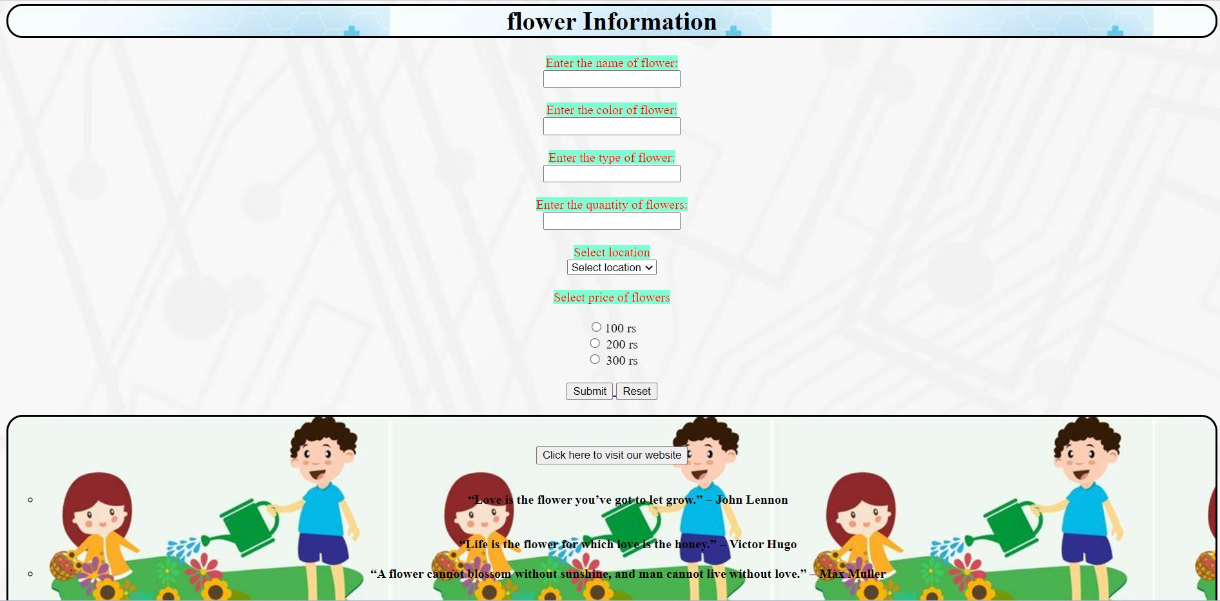

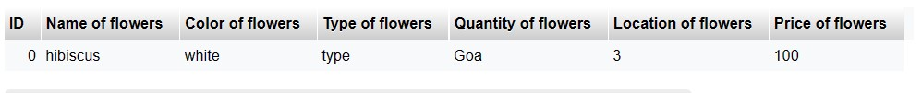

**iii. Data deletion**

<?php

$conn=mysqli_connect("localhost","root","","personal_details");

if($conn)

{

echo"connected";

}

else

{

echo"connection failed";

exit();

}

$q5="DELETE FROM b_flowers WHERE ID='0'";

$r5=mysqli_query($conn,$q5);

if($r5)

{

echo"<br>Data deleted successfully";

}

else

{

echo"<br>Data deletion failed";

}

mysqli_close($conn);

?>

**OUTPUT:**

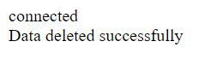



**iv. Update**

<?php

$conn=mysqli_connect("localhost","root","","personal_details");

if($conn)

{

echo"connected";

}

else

{

echo"connection failed";

exit();

}

$q5="UPDATE form_details SET name='jerry' WHERE ID='12'";

$r5=mysqli_query($conn,$q5);

if($r5)

{

echo"<br>Data updated successfully";

}

else

{

echo"<br>Data updation failed";

}

mysqli_close($conn);

?>

**OUTPUT:**

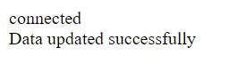



**v. Display**

<?php

$conn=mysqli_connect("localhost","root","","personal_details");

if($conn)

{

echo"connected";

}

else

{

echo"connection failed";

exit();

}

$q5="SELECT * FROM b_flowers";

$r5=mysqli_query($conn,$q5);

$n=mysqli_num_rows($r5);

echo"<br>Number of records= ".$n;

if($r5)

{

while($info=mysqli_fetch_array($r5))

{

echo"<br> ID is ".$info['ID'];

echo"<br> Name is ".$info['Name of flowers'];

echo"<br> color is ".$info['Color of flowers'];

echo"<br> Type is ".$info['Type of flowers'];

echo"<br> Quantity is ".$info['Quantity of flowers'];

echo"<br> Location is ".$info['Location of flowers'];

echo"<br> Price is ".$info['Price of flowers'];

}

}

else

echo"<br>no record found";

?>

**OUTPUT:**

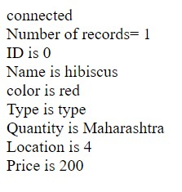

**vi. Search**

<?php

$conn=mysqli_connect("localhost","root","","personal_details");

if($conn)

{

echo"connected";

}

else

{

echo"connection failed";

exit();

}

$q5="SELECT * FROM b_flowers WHERE ID='0'";

$r5=mysqli_query($conn,$q5);

if($r5)

{

$n=mysqli_num_rows($r5);

if($n>0)

{

while($info=mysqli_fetch_array($r5))

{

echo"<br> ID is ".$info['ID'];

echo"<br> Name is ".$info['Name of flowers'];

echo"<br> color is ".$info['Color of flowers'];

echo"<br> Type is ".$info['Type of flowers'];

echo"<br> Quantity is ".$info['Quantity of flowers'];

echo"<br> Location is ".$info['Location of flowers'];

echo"<br> Price is ".$info['Price of flowers'];

}

}

else

echo"<br>no record found";

}

else

{

echo"<br>error in search operation";

}

mysqli_close($conn);

?>

**OUTPUT:**

